**ASSIGNMENT-4**

**Question 1:**

Pull an Image from docker hub and run it in docker playground.

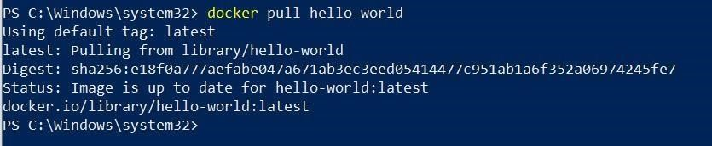

**Question 2:**

Create a docker file for the jobportal application and deploy it in Docker desktop application.

FROM helloworld:latest

WORKDIR ~/Desktop/

ADD . helloworld/

WORKDIR ~/Desktop/htmlfile

RUN pip install -r requirements

RUN chmod +x app.sh

CMD ["/bin/sh","app.sh"]

**Question 3:**

Create a IBM container registry and deploy helloworld app or jobportalapp.

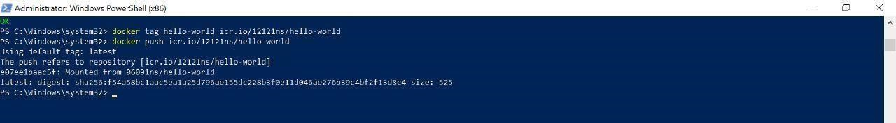

**Question 4:**

Create a Kubernetes cluster in IBM cloud and deploy helloworld image or jobportal image and also expose the same app to run in nodeport.

